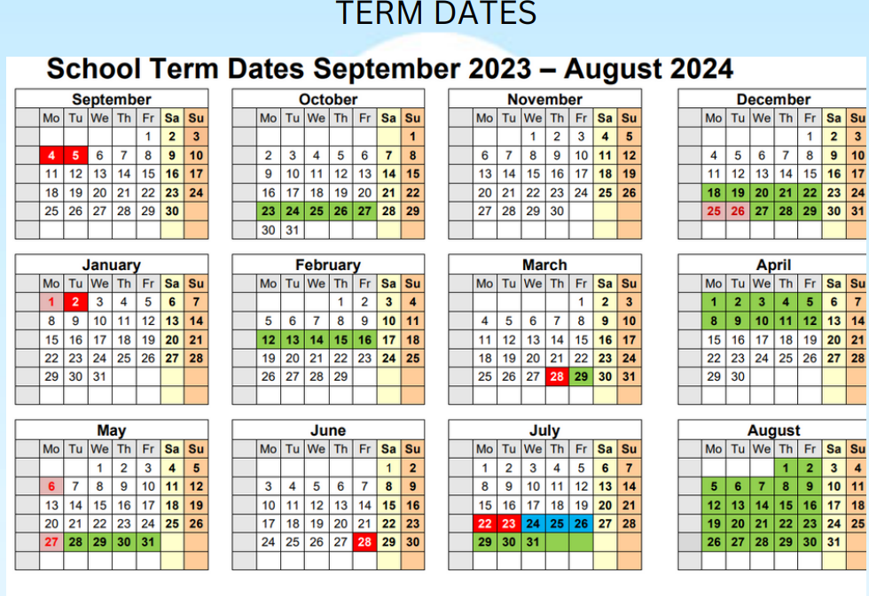

Term Dates 2024/2025
Autumn term Starts: Wednesday 4th September 2024
Half term: Monday 28 October to Friday 1st November 2024
Autumn term ends: Friday 20th December 2024 Christmas holiday Monday 23rd December 2024 to Monday 6th January 2025
Spring term Starts: Tuesday 7th January 2025 Half term: Monday 17th February to Friday 21st February 2025
Spring term ends: Thursday 3rd April 2025 Easter holiday Monday 7th April to Monday 21st April 2025
Summer term Starts: Tuesday 22nd April 2025 Half term: Monday 26th May to Friday 30th May 2025 Summer term ends: Wednesday 16th July 2025

